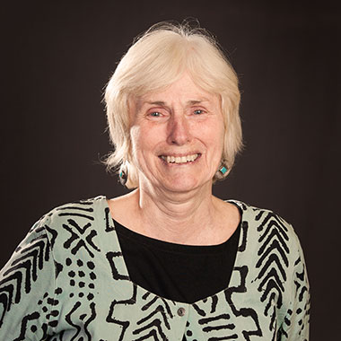

Linda Nettekoven is a community organizer with a background in public health. Linda’s choice of work, both paid and volunteer, reflects a long-time commitment to helping groups and individuals “find their voice” whether in the workplace, the neighborhood, or the public policy arena. Linda has a Masters degree in Organizational, Community and Health Psychology from the University of Oregon. She has done community development work focused on health and housing in a variety of settings from urban inner cities to small towns and rural areas.
In Portland, she has been actively engaged in community involvement and neighborhood planning and transportation issues for nearly 20 years. A long-time neighborhood association board member and former Co-Chair of the Southeast Uplift Neighborhood Coalition she has played a leadership role in Portland’s neighborhood system and has served on numerous citywide advisory bodies. Linda was a founding member of Southeast Uplift’s Diversity Committee, worked on drafting the Community Connect Plan and has served on the Public Involvement Advisory Council and the Community Involvement Committee, charged with improving engagement in the City’s Comprehensive Plan. She was a founding member of the Division Vision Coalition and the Division Design Initiative and has served as a budget advisory committee member for the Office of Neighborhood Involvement, the Bureau of Planning and Sustainability and the Bureau of Transportation.
Linda currently serves on the Board of Craft 3, a community development financial institution focused on family, economic and environmental resilience. She is the recipient of a Spirit of Portland Award and was honored as one of the Daily Journal of Commerce’s Women of Vision in 2018.

