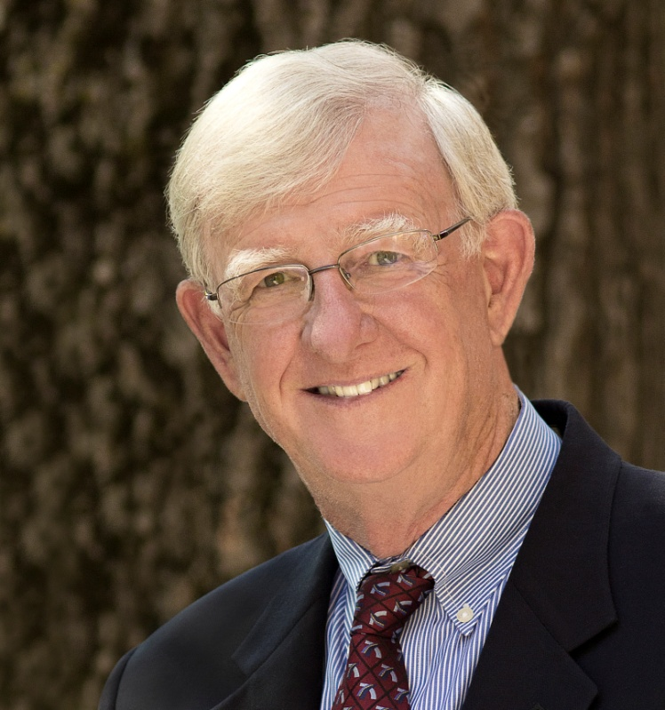

Al Jubitz

A native Oregonian, Al graduated from Yale University (BS) in 1966 and received his MBA from the University of Oregon, School of Business two years later. His business career spanned numerous assignments with Jubitz Corporation in Portland, Oregon, including growing the DAT Services division over 20 years prior to its sale in 2001 when he established his foundation.

As President and founder of the Jubitz Family Foundation, Al oversees its grantmaking and partnerships with organizations that foster peacebuilding and environmental stewardship. The Foundation’s main program, the War Prevention Initiative, is active in the academic research of peace science and is challenged by Al’s goal to prevent all war by the year 2030. In support of that goal Al co-founded the Rotary Action Group for Peace in 2012 and continues to work through Rotary on various peacebuilding initiatives.

A third generation Rotarian, he is Past President and remains an active member of the Rotary Club of Portland (Oregon, USA). Al joined Rotary in 1977 and the Arch Klumph Society in 2007.

Al and his wife Nancy have three daughters and five grandchildren. Enjoying retirement, Al enjoys playing squash and golf, and spending most days managing projects at the family-owned equestrian center, French Hill Farm, in Oregon.

